**Assignment 1 (CLO 1) 10 marks**

**Bernoulli Equation**

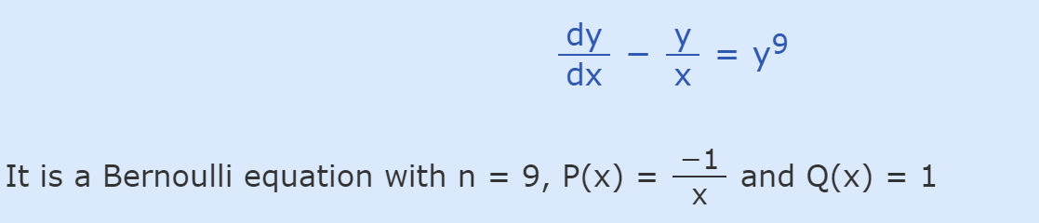

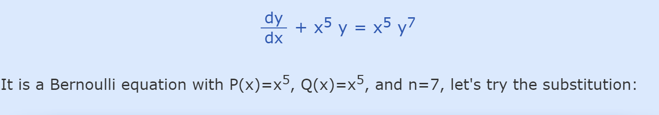

**Separable Equation**

Solve separable differential equations

dy/dx = (x2 + 6)(y - 7)

dy/dx = yex

y' = xy - 3x + 4y - 12